Email Verification

📧 What is Email Verification?
# Source: AI Source: Provided by: [Data Path: Persons Table -> ID Column: 1, Name_En Column: Motasem Essam] -> From: [ChatGPT] on [1/18/2026]
Email verification is the process of confirming that an email address belongs to the user and is valid and reachable. It ensures the person using the email is its owner and can receive messages.

🔹 Why Do We Use Email Verification?
# Source: AI Source: Provided by: [Data Path: Persons Table -> ID Column: 1, Name_En Column: Motasem Essam] -> From: [ChatGPT] on [1/18/2026]
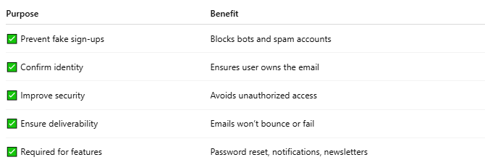

Purpose | Benefit
✅ Prevent fake sign-ups | Blocks bots and spam accounts
✅ Confirm identity | Ensures user owns the email
✅ Improve security | Avoids unauthorized access
✅ Ensure deliverability | Emails won’t bounce or fail
✅ Required for features | Password reset, notifications, newsletters

🔸 Common Use Cases
# Source: AI Source: Provided by: [Data Path: Persons Table -> ID Column: 1, Name_En Column: Motasem Essam] -> From: [ChatGPT] on [1/18/2026]
- Account Sign-Up
→ User enters an email → System sends verification link → User clicks link to activate account.
- Password Reset
→ A secure link is sent to the user’s verified email.
- Email Change Confirmation
→ When changing email, both old and new addresses are verified.

🔄 How Email Verification Works (Flow)
# Source: AI Source: Provided by: [Data Path: Persons Table -> ID Column: 1, Name_En Column: Motasem Essam] -> From: [ChatGPT] on [1/18/2026]
- ✅ User enters email
- 📤 System sends a unique link or code
- 📥 User receives the email
- 🔐 User clicks the link or enters the code
- 🟢 System confirms the email is verified

🔐 Email Verification Example (Link-Based)
# Source: AI Source: Provided by: [Data Path: Persons Table -> ID Column: 1, Name_En Column: Motasem Essam] -> From: [ChatGPT] on [1/18/2026]
Email Message:
Subject: Verify Your Email Address
Click the link to verify your email:
https://example.com/verify?token=abcd1234

🛠️ Tools Used for Email Verification
# Source: AI Source: Provided by: [Data Path: Persons Table -> ID Column: 1, Name_En Column: Motasem Essam] -> From: [ChatGPT] on [1/18/2026]
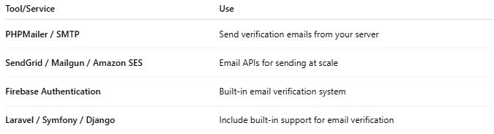

Tool/Service | Use
PHPMailer / SMTP | Send verification emails from your server
SendGrid / Mailgun / Amazon SES | Email APIs for sending at scale
Firebase Authentication | Built-in email verification system
Laravel / Symfony / Django | Include built-in support for email verification

✅ Bonus: Example in PHP using PHPMailer
# Source: AI Source: Provided by: [Data Path: Persons Table -> ID Column: 1, Name_En Column: Motasem Essam] -> From: [ChatGPT] on [1/18/2026]
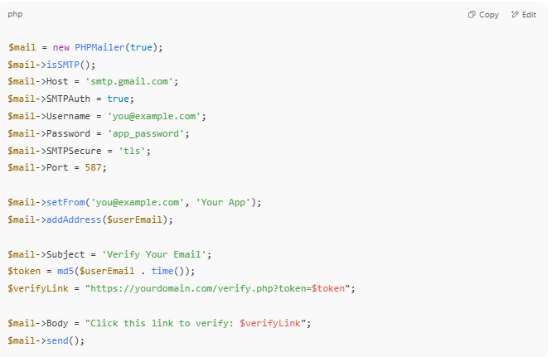
$mail = new PHPMailer(true);
$mail->isSMTP();
$mail->Host = 'smtp.gmail.com';
$mail->SMTPAuth = true;
$mail->Username = 'you@example.com';
$mail->Password = 'app_password';
$mail->SMTPSecure = 'tls';
$mail->Port = 587;

$mail->setFrom('you@example.com', 'Your App');
$mail->addAddress($userEmail);

$mail->Subject = 'Verify Your Email';
$token = md5($userEmail . time());
$verifyLink = "https://yourdomain.com/verify.php?token=$token";

$mail->Body = "Click this link to verify: $verifyLink";
$mail->send();

